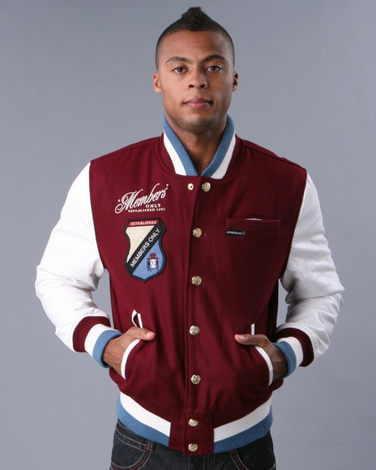

**In this picture:**

**Base colour: red**

**Middle colour: white**

**Outer colour: blue**

This 3 coloured knit pattern should be added to all the jacket apps.

Call it “3 Stripes”. The base colour is always closest to the jacket as can be seen in the picture.

Please make it so that the 3 stripe colours are of equal proportion. No 1 stripe should be thicker than the other.

The 3 options in this design will be;

1. Base Colour
2. Middle Colour
3. Outer Colour

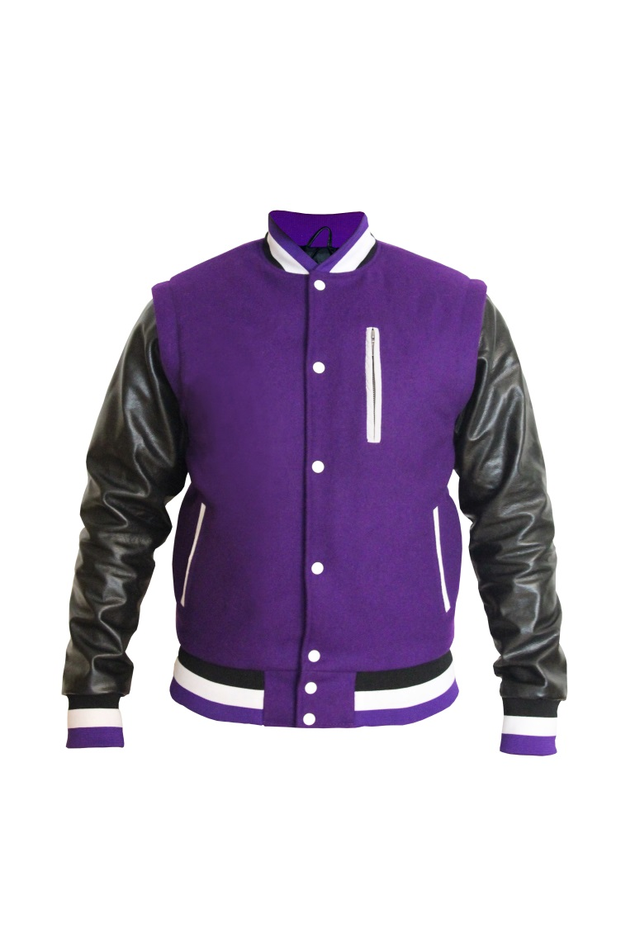

**In this picture:**

**Base colour: black**

**Middle colour: white**

**Outer colour: purple**

